Andrew Dykman, Lab 1.2

Application Characteristics

Single Form | Yes
Includes Graphics | No
Meets Requested Specifications | Yes
Has Multiple Objects | Yes
Is User-Friendly | Yes

Application Sketch:

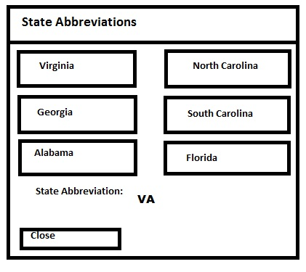

Types of Application Controls and Names:

btnClose | Button
btnVirginia | Button
btnNorthCarolina | Button
btnSouthCarolina | Button
btnGeorgia | Button
btnFlorida | Button
btnAlabama | Button
lblStateAbbreviation | Label
lblStateAbbreviationDescription | Label
lblAppDescription | Label

Default Text Property for Each Control:
btnClose | Close
btnVirginia | Virginia
btnNorthCarolina | North Carolina
btnSouthCarolina | South Carolina
btnGeorgia | Georgia
btnFlorida | Florida
btnAlabama | Alabama
lblStateAbbreviation | (blank)
lblStateAbbreviationDescription | State Abbreviation:
lblAppDescription | Click a button to see that State's Abbreviation!

Event Procedures the Program Requires:
btnClose | Clicked
btnVirginia | Clicked
btnNorthCarolina | Clicked
btnSouthCarolina | Clicked
btnGeorgia | Clicked
btnFlorida | Clicked
btnAlabama | Clicked

Application Flowchart:
